# 20210525
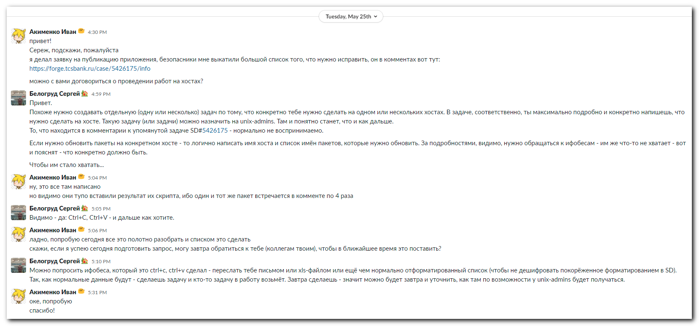

# 20210527
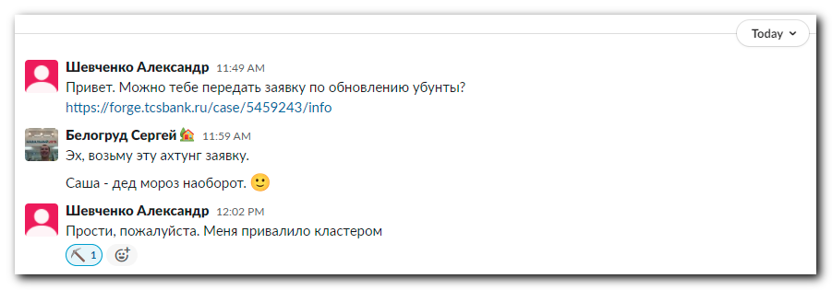

https://forge.tcsbank.ru/case/5459243/info
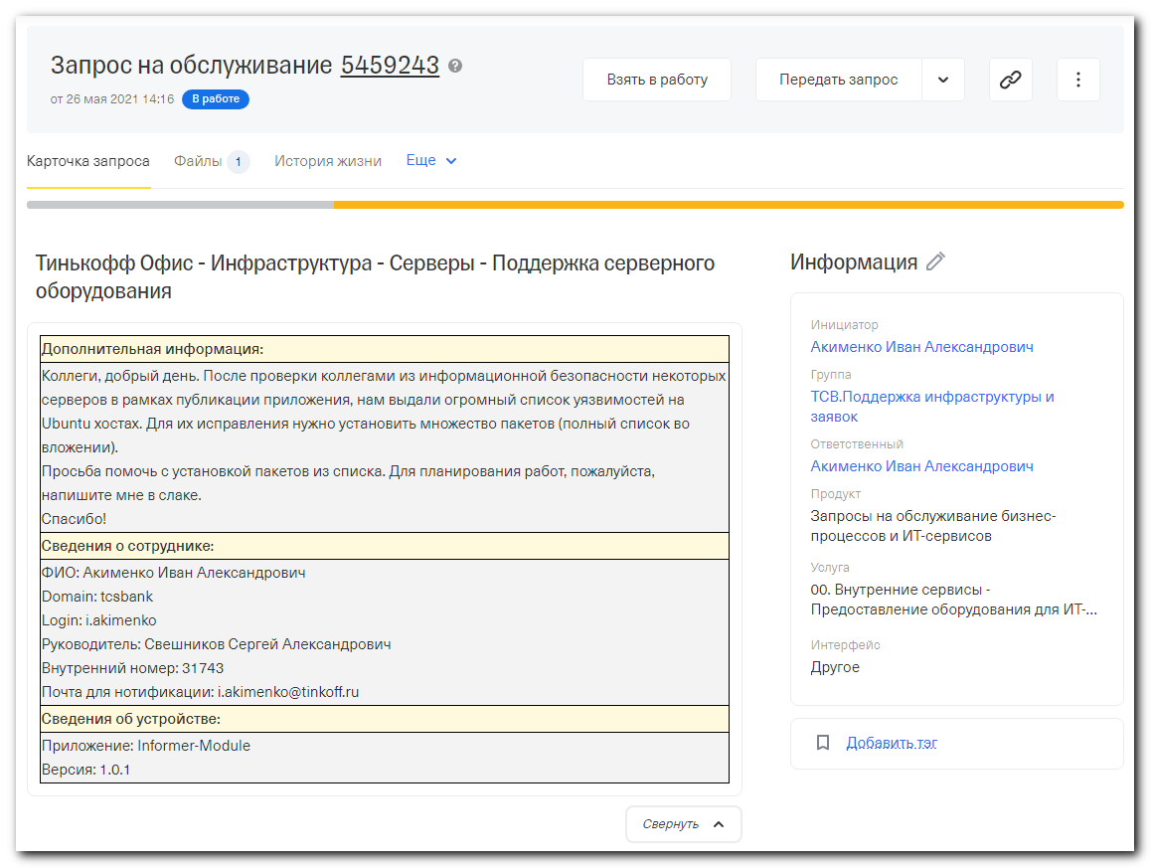
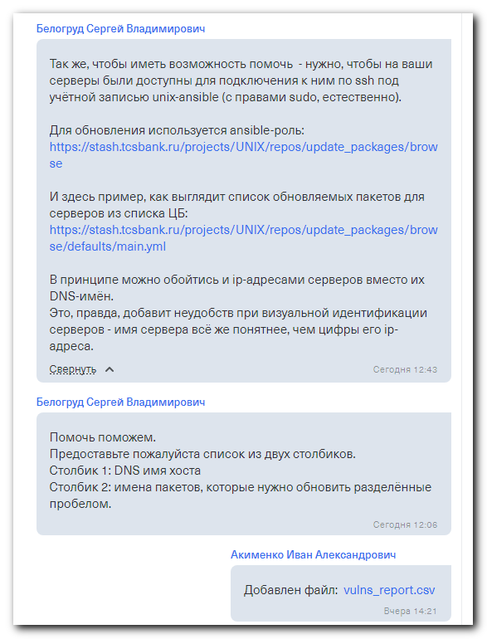

# This is attached file.
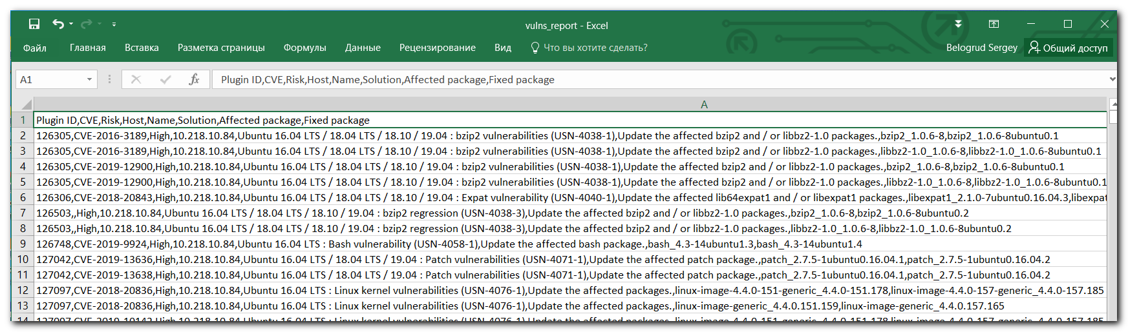

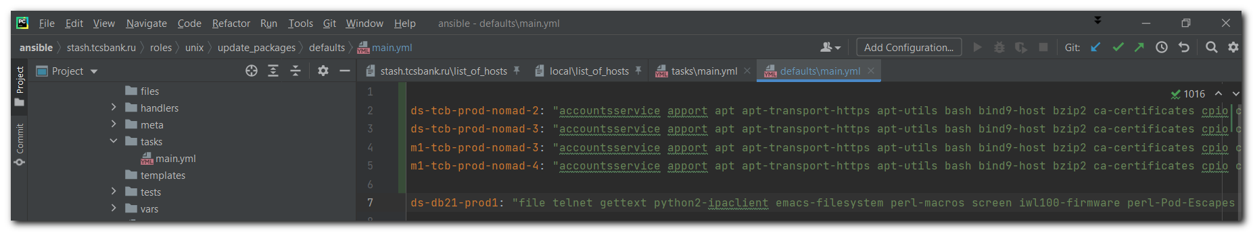
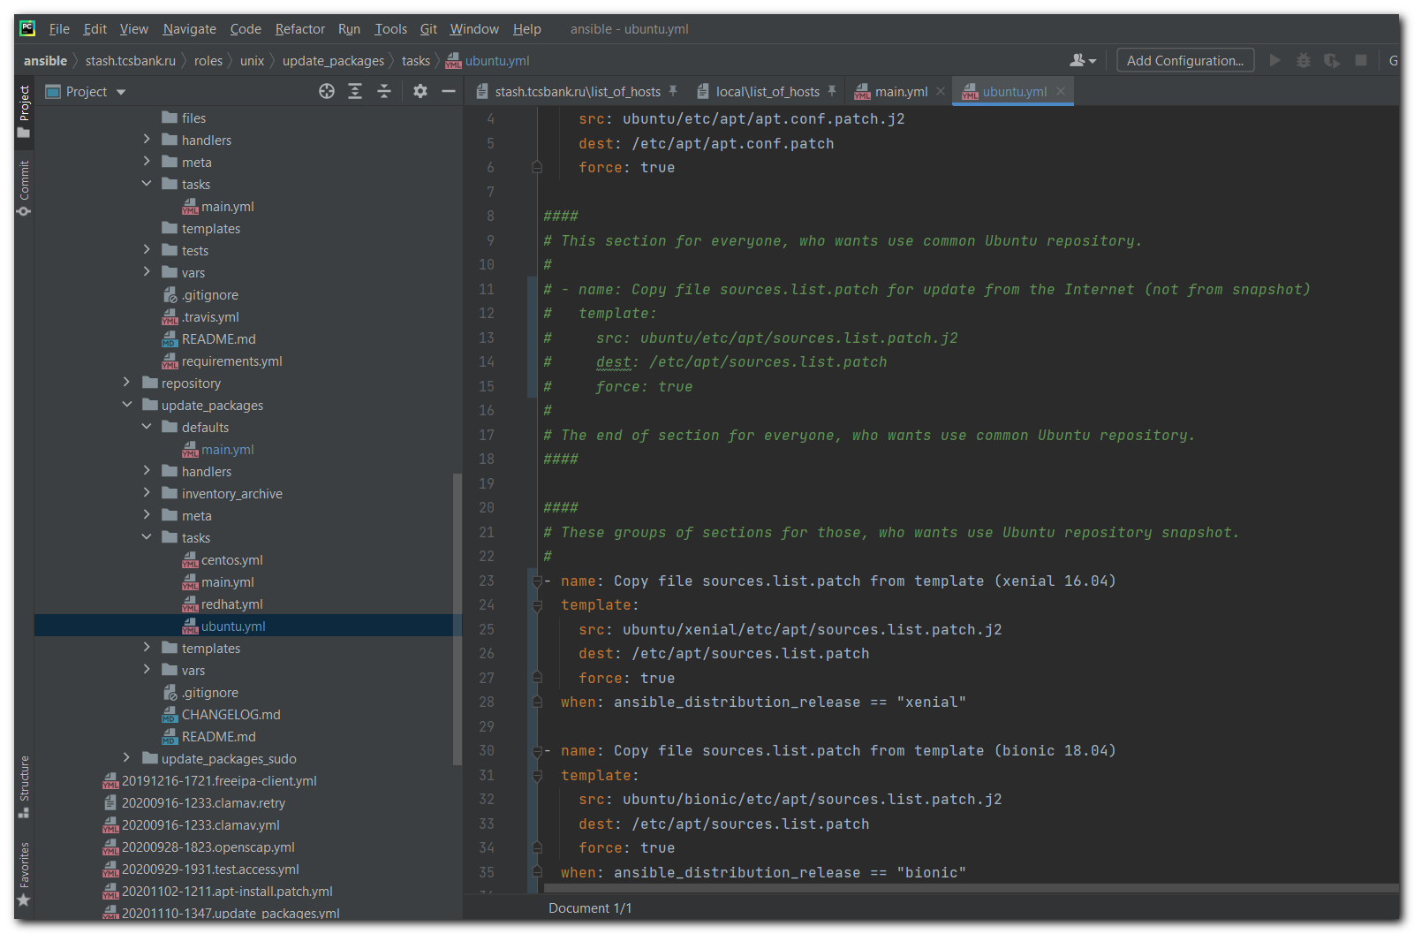

#
# For manual usage.
#
apt-get --purge autoremove
apt-mark showauto 'linux-image-.*'

# For Nagios downtime comment.
JIRA#IN-1154 Update packages on the server

ds-tcb-prod-nomad-2: "accountsservice apport apt apt-transport-https apt-utils bash bind9-host bzip2 ca-certificates cpio curl dbus dnsmasq-base dnsutils e2fsprogs file git git-man intel-microcode krb5-locales libaccountsservice0 libapt-inst2.0 libapt-pkg5.0 libarchive13 libbind9-140 libbsd0 libbz2-1.0 libc-bin libc6 libcurl3-gnutls libdbus-1-3 libdns-export162 libdns162 libexpat1 libfreetype6 libgcrypt20 libglib2.0-0 libglib2.0-data libgnutls30 libgssapi-krb5-2 libhogweed4 libicu55 libisc-export160 libisc160 libisccc140 libisccfg140 libjson-c2 libk5crypto3 libkrb5-3 libkrb5support0 libldap-2.4-2 libldb1 liblwres141 libmagic1 libmspack0 libmysqlclient20 libnettle6 libp11-kit0 libpcap0.8 libperl5.22 libpq5 libpython2.7 libpython2.7-minimal libpython2.7-stdlib libpython3.5 libpython3.5-minimal libpython3.5-stdlib libsasl2-2 libsmbclient libsnmp-base libsnmp30 libsqlite3-0 libwbclient0 libx11-6 libxml2 libxslt1.1 linux-firmware linux-image-4.4.0-154-generic linux-image-4.4.0-157-generic linux-image-4.4.0-159-generic linux-image-4.4.0-161-generic linux-image-4.4.0-164-generic linux-image-4.4.0-165-generic linux-image-4.4.0-166-generic linux-image-4.4.0-168-generic linux-image-4.4.0-169-generic linux-image-4.4.0-170-generic linux-image-4.4.0-171-generic linux-image-4.4.0-173-generic linux-image-4.4.0-174-generic linux-image-4.4.0-176-generic linux-image-4.4.0-177-generic linux-image-4.4.0-178-generic linux-image-4.4.0-179-generic linux-image-4.4.0-184-generic linux-image-4.4.0-185-generic linux-image-4.4.0-186-generic linux-image-4.4.0-187-generic linux-image-4.4.0-189-generic linux-image-4.4.0-190-generic linux-image-4.4.0-193-generic linux-image-4.4.0-194-generic linux-image-4.4.0-197-generic linux-image-4.4.0-198-generic linux-image-4.4.0-200-generic linux-image-4.4.0-201-generic linux-image-4.4.0-203-generic linux-image-4.4.0-204-generic linux-image-4.4.0-206-generic linux-image-4.4.0-208-generic linux-image-4.4.0-209-generic linux-image-generic locales multiarch-support mysql-common nfs-common nscd patch perl perl-base perl-modules-5.22 python-apt python-apt-common python-ldb python-samba python-urllib3 python2.7 python2.7-minimal python3-apport python3-apt python3-problem-report python3-software-properties python3-urllib3 python3.5 python3.5-minimal rsync samba-common samba-common-bin samba-libs screen smbclient snapd software-properties-common sudo sysstat systemd tar tcpdump unzip vim vim-common vim-runtime zlib1g"

ds-tcb-prod-nomad-3: "accountsservice apport apt apt-transport-https apt-utils bash bind9-host bzip2 ca-certificates cpio curl dbus dnsmasq-base dnsutils e2fsprogs file git git-man intel-microcode krb5-locales libaccountsservice0 libapt-inst2.0 libapt-pkg5.0 libarchive13 libbind9-140 libbsd0 libbz2-1.0 libc-bin libc6 libcurl3-gnutls libdbus-1-3 libdns-export162 libdns162 libexpat1 libfreetype6 libgcrypt20 libglib2.0-0 libglib2.0-data libgnutls30 libgssapi-krb5-2 libhogweed4 libicu55 libisc-export160 libisc160 libisccc140 libisccfg140 libjson-c2 libk5crypto3 libkrb5-3 libkrb5support0 libldap-2.4-2 libldb1 liblwres141 libmagic1 libmspack0 libmysqlclient20 libnettle6 libp11-kit0 libpcap0.8 libperl5.22 libpq5 libpython2.7 libpython2.7-minimal libpython2.7-stdlib libpython3.5 libpython3.5-minimal libpython3.5-stdlib libsasl2-2 libsmbclient libsnmp-base libsnmp30 libsqlite3-0 libwbclient0 libx11-6 libxml2 libxslt1.1 linux-firmware linux-image-4.4.0-154-generic linux-image-4.4.0-157-generic linux-image-4.4.0-159-generic linux-image-4.4.0-161-generic linux-image-4.4.0-164-generic linux-image-4.4.0-165-generic linux-image-4.4.0-166-generic linux-image-4.4.0-168-generic linux-image-4.4.0-169-generic linux-image-4.4.0-170-generic linux-image-4.4.0-171-generic linux-image-4.4.0-173-generic linux-image-4.4.0-174-generic linux-image-4.4.0-176-generic linux-image-4.4.0-177-generic linux-image-4.4.0-178-generic linux-image-4.4.0-179-generic linux-image-4.4.0-184-generic linux-image-4.4.0-185-generic linux-image-4.4.0-186-generic linux-image-4.4.0-187-generic linux-image-4.4.0-189-generic linux-image-4.4.0-190-generic linux-image-4.4.0-193-generic linux-image-4.4.0-194-generic linux-image-4.4.0-197-generic linux-image-4.4.0-198-generic linux-image-4.4.0-200-generic linux-image-4.4.0-201-generic linux-image-4.4.0-203-generic linux-image-4.4.0-204-generic linux-image-4.4.0-206-generic linux-image-4.4.0-208-generic linux-image-4.4.0-209-generic linux-image-generic locales multiarch-support mysql-common nfs-common nscd patch perl perl-base perl-modules-5.22 python-apt python-apt-common python-ldb python-samba python-urllib3 python2.7 python2.7-minimal python3-apport python3-apt python3-problem-report python3-software-properties python3-urllib3 python3.5 python3.5-minimal rsync samba-common samba-common-bin samba-libs screen smbclient snapd software-properties-common sudo sysstat systemd tar tcpdump unzip vim vim-common vim-runtime zlib1g"

m1-tcb-prod-nomad-3: "accountsservice apport apt apt-transport-https apt-utils bash bind9-host bzip2 ca-certificates cpio curl dbus dnsmasq-base dnsutils e2fsprogs file git git-man intel-microcode krb5-locales libaccountsservice0 libapt-inst2.0 libapt-pkg5.0 libarchive13 libbind9-140 libbsd0 libbz2-1.0 libc-bin libc6 libcurl3-gnutls libdbus-1-3 libdns-export162 libdns162 libexpat1 libfreetype6 libgcrypt20 libglib2.0-0 libglib2.0-data libgnutls30 libgssapi-krb5-2 libhogweed4 libicu55 libisc-export160 libisc160 libisccc140 libisccfg140 libjson-c2 libk5crypto3 libkrb5-3 libkrb5support0 libldap-2.4-2 libldb1 liblwres141 libmagic1 libmspack0 libmysqlclient20 libnettle6 libp11-kit0 libpcap0.8 libperl5.22 libpq5 libpython2.7 libpython2.7-minimal libpython2.7-stdlib libpython3.5 libpython3.5-minimal libpython3.5-stdlib libsasl2-2 libsmbclient libsnmp-base libsnmp30 libsqlite3-0 libwbclient0 libx11-6 libxml2 libxslt1.1 linux-firmware linux-image-4.4.0-154-generic linux-image-4.4.0-157-generic linux-image-4.4.0-159-generic linux-image-4.4.0-161-generic linux-image-4.4.0-164-generic linux-image-4.4.0-165-generic linux-image-4.4.0-166-generic linux-image-4.4.0-168-generic linux-image-4.4.0-169-generic linux-image-4.4.0-170-generic linux-image-4.4.0-171-generic linux-image-4.4.0-173-generic linux-image-4.4.0-174-generic linux-image-4.4.0-176-generic linux-image-4.4.0-177-generic linux-image-4.4.0-178-generic linux-image-4.4.0-179-generic linux-image-4.4.0-184-generic linux-image-4.4.0-185-generic linux-image-4.4.0-186-generic linux-image-4.4.0-187-generic linux-image-4.4.0-189-generic linux-image-4.4.0-190-generic linux-image-4.4.0-193-generic linux-image-4.4.0-194-generic linux-image-4.4.0-197-generic linux-image-4.4.0-198-generic linux-image-4.4.0-200-generic linux-image-4.4.0-201-generic linux-image-4.4.0-203-generic linux-image-4.4.0-204-generic linux-image-4.4.0-206-generic linux-image-4.4.0-208-generic linux-image-4.4.0-209-generic linux-image-generic locales multiarch-support mysql-common nfs-common nscd patch perl perl-base perl-modules-5.22 python-apt python-apt-common python-ldb python-samba python-urllib3 python2.7 python2.7-minimal python3-apport python3-apt python3-problem-report python3-software-properties python3-urllib3 python3.5 python3.5-minimal rsync samba-common samba-common-bin samba-libs screen smbclient snapd software-properties-common sudo sysstat systemd tar tcpdump unzip vim vim-common vim-runtime zlib1g"

m1-tcb-prod-nomad-4: "accountsservice apport apt apt-transport-https apt-utils bash bind9-host bzip2 ca-certificates cpio curl dbus dnsmasq-base dnsutils e2fsprogs file git git-man intel-microcode krb5-locales libaccountsservice0 libapt-inst2.0 libapt-pkg5.0 libarchive13 libbind9-140 libbsd0 libbz2-1.0 libc-bin libc6 libcurl3-gnutls libdbus-1-3 libdns-export162 libdns162 libexpat1 libfreetype6 libgcrypt20 libglib2.0-0 libglib2.0-data libgnutls30 libgssapi-krb5-2 libhogweed4 libicu55 libisc-export160 libisc160 libisccc140 libisccfg140 libjson-c2 libk5crypto3 libkrb5-3 libkrb5support0 libldap-2.4-2 libldb1 liblwres141 libmagic1 libmspack0 libmysqlclient20 libnettle6 libp11-kit0 libpcap0.8 libperl5.22 libpq5 libpython2.7 libpython2.7-minimal libpython2.7-stdlib libpython3.5 libpython3.5-minimal libpython3.5-stdlib libsasl2-2 libsmbclient libsnmp-base libsnmp30 libsqlite3-0 libwbclient0 libx11-6 libxml2 libxslt1.1 linux-firmware linux-image-4.4.0-154-generic linux-image-4.4.0-157-generic linux-image-4.4.0-159-generic linux-image-4.4.0-161-generic linux-image-4.4.0-164-generic linux-image-4.4.0-165-generic linux-image-4.4.0-166-generic linux-image-4.4.0-168-generic linux-image-4.4.0-169-generic linux-image-4.4.0-170-generic linux-image-4.4.0-171-generic linux-image-4.4.0-173-generic linux-image-4.4.0-174-generic linux-image-4.4.0-176-generic linux-image-4.4.0-177-generic linux-image-4.4.0-178-generic linux-image-4.4.0-179-generic linux-image-4.4.0-184-generic linux-image-4.4.0-185-generic linux-image-4.4.0-186-generic linux-image-4.4.0-187-generic linux-image-4.4.0-189-generic linux-image-4.4.0-190-generic linux-image-4.4.0-193-generic linux-image-4.4.0-194-generic linux-image-4.4.0-197-generic linux-image-4.4.0-198-generic linux-image-4.4.0-200-generic linux-image-4.4.0-201-generic linux-image-4.4.0-203-generic linux-image-4.4.0-204-generic linux-image-4.4.0-206-generic linux-image-4.4.0-208-generic linux-image-4.4.0-209-generic linux-image-generic locales multiarch-support mysql-common nfs-common nscd patch perl perl-base perl-modules-5.22 python-apt python-apt-common python-ldb python-samba python-urllib3 python2.7 python2.7-minimal python3-apport python3-apt python3-problem-report python3-software-properties python3-urllib3 python3.5 python3.5-minimal rsync samba-common samba-common-bin samba-libs screen smbclient snapd software-properties-common sudo sysstat systemd tar tcpdump unzip vim vim-common vim-runtime zlib1g"

#
# I temporary made some changes in these files.
# Were added strings for four servers for this task.
# And I uncommented section for update from snapshot (and commented section for update from free repository). This way I tested how works snapshot.
#
[s.belogrud@nb2339]# git status
На ветке development
Изменения, которые не в индексе для коммита:
(используйте «git add <файл>…», чтобы добавить файл в индекс)
(используйте «git checkout -- <файл>…», чтобы отменить изменения
в рабочем каталоге)

изменено: defaults/main.yml
изменено: tasks/ubuntu.yml

нет изменений добавленных для коммита
(используйте «git add» и/или «git commit -a»)
[s.belogrud@nb2339]#

[support@nb2339]# export ANSIBLE_CONFIG=ansible.cfg ; logfile="$(date +%Y%m%d-%H%M).playbook.log.txt" ; ansible-playbook 20201110-1347.update_packages.yml -i list_of_hosts --become --extra-vars "ansible_user=unix-ansible ansible_password=$(pass common/linux-unix-ansible) ansible_sudo_pass=$(pass common/linux-unix-ansible) ansible_ssh_common_args='-oStrictHostKeyChecking=no -oPubkeyAuthentication=no -oUserKnownHostsFile=/dev/null'" --check --diff | tee -a ./output/${logfile}

#
# Here is an example - how looks saved log.
# It was manually saved in ~ directory, because after updates the sever was rebooted and during new start the directory /tmp was cleaned.
#
root@m1-tcb-prod-nomad-4:~# cat ~/work/20210608-0104/20210608-0100.m1-tcb-prod-nomad-4.update_packages.txt
# BEGIN ANSIBLE MANAGED BLOCK --- Update apt cache, but use apt.conf.patch
shell: 'apt -c /etc/apt/apt.conf.patch update'
Get:1 http://repo-linux.tcsbank.ru/ubuntu-snapshots/202106xx xenial InRelease [247 kB]
Get:2 http://repo-linux.tcsbank.ru/ubuntu-snapshots/202106xx xenial-updates InRelease [109 kB]
Get:3 http://repo-linux.tcsbank.ru/ubuntu-snapshots/202106xx xenial-backports InRelease [107 kB]
...
Get:35 http://repo-linux.tcsbank.ru/ubuntu-snapshots/202106xx xenial-security/universe amd64 Packages [785 kB]
Get:36 http://repo-linux.tcsbank.ru/ubuntu-snapshots/202106xx xenial-security/universe i386 Packages [665 kB]
Get:37 http://repo-linux.tcsbank.ru/ubuntu-snapshots/202106xx xenial-security/universe Translation-en [225 kB]
Fetched 34.6 MB in 7s (4,484 kB/s)
Reading package lists...
Building dependency tree...
Reading state information...
193 packages can be upgraded. Run 'apt list --upgradable' to see them.

# END ANSIBLE MANAGED BLOCK --- Update apt cache, but use apt.conf.patch
# BEGIN ANSIBLE MANAGED BLOCK --- Print info about host and packages to update
Host name = m1-tcb-prod-nomad-4
Packages to update = accountsservice apport apt apt-transport-https apt-utils bash bind9-host bzip2 ca-certificates cpio curl dbus dnsmasq-base d
nsutils e2fsprogs file git git-man intel-microcode krb5-locales libaccountsservice0 libapt-inst2.0 libapt-pkg5.0 libarchive13 libbind9-140 libbsd0 libbz2
-1.0 libc-bin libc6 libcurl3-gnutls libdbus-1-3 libdns-export162 libdns162 libexpat1 libfreetype6 libgcrypt20 libglib2.0-0 libglib2.0-data libgnutls30 li
bgssapi-krb5-2 libhogweed4 libicu55 libisc-export160 libisc160 libisccc140 libisccfg140 libjson-c2 libk5crypto3 libkrb5-3 libkrb5support0 libldap-2.4-2 l
ibldb1 liblwres141 libmagic1 libmspack0 libmysqlclient20 libnettle6 libp11-kit0 libpcap0.8 libperl5.22 libpq5 libpython2.7 libpython2.7-minimal libpython
2.7-stdlib libpython3.5 libpython3.5-minimal libpython3.5-stdlib libsasl2-2 libsmbclient libsnmp-base libsnmp30 libsqlite3-0 libwbclient0 libx11-6 libxml
2 libxslt1.1 linux-firmware linux-image-4.4.0-154-generic linux-image-4.4.0-157-generic linux-image-4.4.0-159-generic linux-image-4.4.0-161-generic linux
-image-4.4.0-164-generic linux-image-4.4.0-165-generic linux-image-4.4.0-166-generic linux-image-4.4.0-168-generic linux-image-4.4.0-169-generic linux-im
age-4.4.0-170-generic linux-image-4.4.0-171-generic linux-image-4.4.0-173-generic linux-image-4.4.0-174-generic linux-image-4.4.0-176-generic linux-image
-4.4.0-177-generic linux-image-4.4.0-178-generic linux-image-4.4.0-179-generic linux-image-4.4.0-184-generic linux-image-4.4.0-185-generic linux-image-4.
4.0-186-generic linux-image-4.4.0-187-generic linux-image-4.4.0-189-generic linux-image-4.4.0-190-generic linux-image-4.4.0-193-generic linux-image-4.4.0
-194-generic linux-image-4.4.0-197-generic linux-image-4.4.0-198-generic linux-image-4.4.0-200-generic linux-image-4.4.0-201-generic linux-image-4.4.0-20
3-generic linux-image-4.4.0-204-generic linux-image-4.4.0-206-generic linux-image-4.4.0-208-generic linux-image-4.4.0-209-generic linux-image-generic loc
ales multiarch-support mysql-common nfs-common nscd patch perl perl-base perl-modules-5.22 python-apt python-apt-common python-ldb python-samba python-ur
llib3 python2.7 python2.7-minimal python3-apport python3-apt python3-problem-report python3-software-properties python3-urllib3 python3.5 python3.5-minim
al rsync samba-common samba-common-bin samba-libs screen smbclient snapd software-properties-common sudo sysstat systemd tar tcpdump unzip vim vim-common
vim-runtime zlib1g

# END ANSIBLE MANAGED BLOCK --- Print info about host and packages to update
# BEGIN ANSIBLE MANAGED BLOCK --- Update packages
shell: 'apt install --only-upgrade --assume-yes -c /etc/apt/apt.conf.patch accountsservice apport apt apt-transport-https apt-utils bash bind9-ho
st bzip2 ca-certificates cpio curl dbus dnsmasq-base dnsutils e2fsprogs file git git-man intel-microcode krb5-locales libaccountsservice0 libapt-inst2.0
libapt-pkg5.0 libarchive13 libbind9-140 libbsd0 libbz2-1.0 libc-bin libc6 libcurl3-gnutls libdbus-1-3 libdns-export162 libdns162 libexpat1 libfreetype6 l
ibgcrypt20 libglib2.0-0 libglib2.0-data libgnutls30 libgssapi-krb5-2 libhogweed4 libicu55 libisc-export160 libisc160 libisccc140 libisccfg140 libjson-c2
libk5crypto3 libkrb5-3 libkrb5support0 libldap-2.4-2 libldb1 liblwres141 libmagic1 libmspack0 libmysqlclient20 libnettle6 libp11-kit0 libpcap0.8 libperl5
.22 libpq5 libpython2.7 libpython2.7-minimal libpython2.7-stdlib libpython3.5 libpython3.5-minimal libpython3.5-stdlib libsasl2-2 libsmbclient libsnmp-ba
se libsnmp30 libsqlite3-0 libwbclient0 libx11-6 libxml2 libxslt1.1 linux-firmware linux-image-4.4.0-154-generic linux-image-4.4.0-157-generic linux-image
-4.4.0-159-generic linux-image-4.4.0-161-generic linux-image-4.4.0-164-generic linux-image-4.4.0-165-generic linux-image-4.4.0-166-generic linux-image-4.
4.0-168-generic linux-image-4.4.0-169-generic linux-image-4.4.0-170-generic linux-image-4.4.0-171-generic linux-image-4.4.0-173-generic linux-image-4.4.0
-174-generic linux-image-4.4.0-176-generic linux-image-4.4.0-177-generic linux-image-4.4.0-178-generic linux-image-4.4.0-179-generic linux-image-4.4.0-18
4-generic linux-image-4.4.0-185-generic linux-image-4.4.0-186-generic linux-image-4.4.0-187-generic linux-image-4.4.0-189-generic linux-image-4.4.0-190-g
eneric linux-image-4.4.0-193-generic linux-image-4.4.0-194-generic linux-image-4.4.0-197-generic linux-image-4.4.0-198-generic linux-image-4.4.0-200-gene
ric linux-image-4.4.0-201-generic linux-image-4.4.0-203-generic linux-image-4.4.0-204-generic linux-image-4.4.0-206-generic linux-image-4.4.0-208-generic
linux-image-4.4.0-209-generic linux-image-generic locales multiarch-support mysql-common nfs-common nscd patch perl perl-base perl-modules-5.22 python-a
pt python-apt-common python-ldb python-samba python-urllib3 python2.7 python2.7-minimal python3-apport python3-apt python3-problem-report python3-softwar
e-properties python3-urllib3 python3.5 python3.5-minimal rsync samba-common samba-common-bin samba-libs screen smbclient snapd software-properties-common
sudo sysstat systemd tar tcpdump unzip vim vim-common vim-runtime zlib1g'
Reading package lists...
Building dependency tree...
Reading state information...
Skipping linux-image-4.4.0-154-generic, it is not installed and only upgrades are requested.
Skipping linux-image-4.4.0-157-generic, it is not installed and only upgrades are requested.
Skipping linux-image-4.4.0-159-generic, it is not installed and only upgrades are requested.
Skipping linux-image-4.4.0-161-generic, it is not installed and only upgrades are requested.
...
Skipping linux-image-4.4.0-203-generic, it is not installed and only upgrades are requested.
Skipping linux-image-4.4.0-204-generic, it is not installed and only upgrades are requested.
Skipping linux-image-4.4.0-206-generic, it is not installed and only upgrades are requested.
Skipping linux-image-4.4.0-208-generic, it is not installed and only upgrades are requested.
Skipping linux-image-4.4.0-209-generic, it is not installed and only upgrades are requested.
The following additional packages will be installed:
e2fslibs libgnutls-openssl27 libpam-systemd libsasl2-modules
libsasl2-modules-db libsystemd0 libzstd1 linux-generic
linux-headers-4.4.0-210 linux-headers-4.4.0-210-generic
linux-headers-generic linux-image-4.4.0-210-generic
linux-modules-4.4.0-210-generic linux-modules-extra-4.4.0-210-generic snmp
vim-tiny
Suggested packages:
gnome-control-center apport-gtk | apport-kde aptitude | synaptic | wajig
dpkg-dev apt-doc bash-doc bzip2-doc libarchive1 dbus-user-session | dbus-x11
rblcheck gpart e2fsck-static git-daemon-run | git-daemon-sysvinit git-doc
git-el git-email git-gui gitk gitweb git-arch git-cvs git-mediawiki git-svn
lrzip glibc-doc rng-tools gnutls-bin krb5-doc krb5-user libsasl2-modules-otp
libsasl2-modules-ldap libsasl2-modules-sql libsasl2-modules-gssapi-mit
| libsasl2-modules-gssapi-heimdal snmp-mibs-downloader fdutils
linux-doc-4.4.0 | linux-source-4.4.0 linux-tools watchdog diffutils-doc
perl-doc libterm-readline-gnu-perl | libterm-readline-perl-perl make
python-apt-dbg python-apt-doc python-ntlm python2.7-doc binutils
binfmt-support python3-launchpadlib python3-apt-dbg python3-ndg-httpsclient
python3-openssl python3-pyasn1 python3.5-venv python3.5-doc heimdal-clients
cifs-utils zenity | kdialog isag systemd-ui systemd-container ncompress
tar-scripts zip ctags vim-doc vim-scripts vim-gnome-py2 | vim-gtk-py2
| vim-gtk3-py2 | vim-athena-py2 | vim-nox-py2 indent
Recommended packages:
thermald python-ndg-httpsclient python-openssl python-pyasn1
unattended-upgrades
The following NEW packages will be installed:
libzstd1 linux-headers-4.4.0-210 linux-headers-4.4.0-210-generic
linux-image-4.4.0-210-generic linux-modules-4.4.0-210-generic
linux-modules-extra-4.4.0-210-generic
The following packages will be upgraded:
accountsservice apport apt apt-transport-https apt-utils bash bind9-host
bzip2 ca-certificates cpio curl dbus dnsmasq-base dnsutils e2fslibs
e2fsprogs file git git-man intel-microcode krb5-locales libaccountsservice0
libapt-inst2.0 libapt-pkg5.0 libarchive13 libbind9-140 libbsd0 libbz2-1.0
libc-bin libc6 libcurl3-gnutls libdbus-1-3 libdns-export162 libdns162
libexpat1 libfreetype6 libgcrypt20 libglib2.0-0 libglib2.0-data
libgnutls-openssl27 libgnutls30 libgssapi-krb5-2 libhogweed4 libicu55
libisc-export160 libisc160 libisccc140 libisccfg140 libjson-c2 libk5crypto3
libkrb5-3 libkrb5support0 libldap-2.4-2 libldb1 liblwres141 libmagic1
libmspack0 libmysqlclient20 libnettle6 libp11-kit0 libpam-systemd libpcap0.8
libperl5.22 libpq5 libpython2.7 libpython2.7-minimal libpython2.7-stdlib
libpython3.5 libpython3.5-minimal libpython3.5-stdlib libsasl2-2
libsasl2-modules libsasl2-modules-db libsmbclient libsnmp-base libsnmp30
libsqlite3-0 libsystemd0 libwbclient0 libx11-6 libxml2 libxslt1.1
linux-firmware linux-generic linux-headers-generic linux-image-generic
locales multiarch-support mysql-common nfs-common nscd patch perl perl-base
perl-modules-5.22 python-apt python-apt-common python-ldb python-samba
python-urllib3 python2.7 python2.7-minimal python3-apport python3-apt
python3-problem-report python3-software-properties python3-urllib3 python3.5
python3.5-minimal rsync samba-common samba-common-bin samba-libs screen
smbclient snapd snmp software-properties-common sudo sysstat systemd tar
tcpdump unzip vim vim-common vim-runtime vim-tiny zlib1g
129 upgraded, 6 newly installed, 0 to remove and 64 not upgraded.
Need to get 214 MB of archives.
After this operation, 342 MB of additional disk space will be used.
Get:1 http://repo-linux.tcsbank.ru/ubuntu-snapshots/202106xx xenial-updates/main amd64 bash amd64 4.3-14ubuntu1.4 [583 kB]
Get:2 http://repo-linux.tcsbank.ru/ubuntu-snapshots/202106xx xenial-updates/main amd64 libc6 amd64 2.23-0ubuntu11.3 [2,590 kB]
...
Get:129 http://repo-linux.tcsbank.ru/ubuntu-snapshots/202106xx xenial-updates/main amd64 software-properties-common all 0.96.20.10 [9,504 B]
Get:130 http://repo-linux.tcsbank.ru/ubuntu-snapshots/202106xx xenial-updates/main amd64 python3-software-properties all 0.96.20.10 [20.2 kB]
Get:131 http://repo-linux.tcsbank.ru/ubuntu-snapshots/202106xx xenial-updates/main amd64 python3-urllib3 all 1.13.1-2ubuntu0.16.04.4 [58.6 kB]
Get:132 http://repo-linux.tcsbank.ru/ubuntu-snapshots/202106xx xenial-updates/main amd64 screen amd64 4.3.1-2ubuntu0.1 [553 kB]
Get:133 http://repo-linux.tcsbank.ru/ubuntu-snapshots/202106xx xenial-updates/main amd64 snapd amd64 2.48.3 [21.1 MB]
Get:134 http://repo-linux.tcsbank.ru/ubuntu-snapshots/202106xx xenial-updates/main amd64 sysstat amd64 11.2.0-1ubuntu0.3 [242 kB]
Get:135 http://repo-linux.tcsbank.ru/ubuntu-snapshots/202106xx xenial-updates/main amd64 unzip amd64 6.0-20ubuntu1.1 [162 kB]
Preconfiguring packages ...
Fetched 214 MB in 14s (14.3 MB/s)
(Reading database ...
(Reading database ... 5%
(Reading database ... 10%
...
(Reading database ... 99635 files and directories currently installed.)
Preparing to unpack .../multiarch-support_2.23-0ubuntu11.3_amd64.deb ...
Unpacking multiarch-support (2.23-0ubuntu11.3) over (2.23-0ubuntu11) ...
Setting up multiarch-support (2.23-0ubuntu11.3) ...
(Reading database ...
(Reading database ... 5%
(Reading database ... 10%
(Reading database ... 15%
(Reading database ... 20%
(Reading database ... 25%
(Reading database ... 30%
(Reading database ... 35%
(Reading database ... 40%
(Reading database ... 45%
(Reading database ... 50%
(Reading database ... 55%
(Reading database ... 60%
(Reading database ... 65%
(Reading database ... 70%
(Reading database ... 75%
(Reading database ... 80%
(Reading database ... 85%
(Reading database ... 90%
(Reading database ... 95%
(Reading database ... 100%
(Reading database ... 99635 files and directories currently installed.)
Preparing to unpack .../cpio_2.11+dfsg-5ubuntu1.1_amd64.deb ...
Unpacking cpio (2.11+dfsg-5ubuntu1.1) over (2.11+dfsg-5ubuntu1) ...
Preparing to unpack .../file_1%3a5.25-2ubuntu1.4_amd64.deb ...
Unpacking file (1:5.25-2ubuntu1.4) over (1:5.25-2ubuntu1.2) ...
...
32 added, 50 removed; done.
Running hooks in /etc/ca-certificates/update.d...
done.
Processing triggers for systemd (229-4ubuntu21.31) ...
Processing triggers for ureadahead (0.100.0-19.1) ...
Processing triggers for linux-image-4.4.0-210-generic (4.4.0-210.242) ...
/etc/kernel/postinst.d/initramfs-tools:
update-initramfs: Generating /boot/initrd.img-4.4.0-210-generic
W: mdadm: /etc/mdadm/mdadm.conf defines no arrays.
/etc/kernel/postinst.d/x-grub-legacy-ec2:
Searching for GRUB installation directory ... found: /boot/grub
Searching for default file ... found: /boot/grub/default
Testing for an existing GRUB menu.lst file ... found: /boot/grub/menu.lst
Searching for splash image ... none found, skipping ...
Found kernel: /vmlinuz-4.4.0-151-generic
Found kernel: /vmlinuz-4.4.0-146-generic
Found kernel: /vmlinuz-4.4.0-210-generic
Found kernel: /vmlinuz-4.4.0-151-generic
Found kernel: /vmlinuz-4.4.0-146-generic
Replacing config file /run/grub/menu.lst with new version
Updating /boot/grub/menu.lst ... done

/etc/kernel/postinst.d/zz-update-grub:
Generating grub configuration file ...
Found linux image: /boot/vmlinuz-4.4.0-210-generic
Found initrd image: /boot/initrd.img-4.4.0-210-generic
Found linux image: /boot/vmlinuz-4.4.0-151-generic
Found initrd image: /boot/initrd.img-4.4.0-151-generic
Found linux image: /boot/vmlinuz-4.4.0-146-generic
Found initrd image: /boot/initrd.img-4.4.0-146-generic
done
Processing triggers for initramfs-tools (0.122ubuntu8.14) ...
update-initramfs: Generating /boot/initrd.img-4.4.0-210-generic
W: mdadm: /etc/mdadm/mdadm.conf defines no arrays.

# END ANSIBLE MANAGED BLOCK --- Update packages
root@m1-tcb-prod-nomad-4:~#

#
# And here is log from the same ansible role, only repeated after couple of minutes late.
# All packages were updated and so on.
#
root@m1-tcb-prod-nomad-4:~# cat ~/work/20210608-0104/20210608-0103.m1-tcb-prod-nomad-4.update_packages.txt
# BEGIN ANSIBLE MANAGED BLOCK --- Update apt cache, but use apt.conf.patch
shell: 'apt -c /etc/apt/apt.conf.patch update'
Hit:1 http://repo-linux.tcsbank.ru/ubuntu-snapshots/202106xx xenial InRelease
Hit:2 http://repo-linux.tcsbank.ru/ubuntu-snapshots/202106xx xenial-updates InRelease
Hit:3 http://repo-linux.tcsbank.ru/ubuntu-snapshots/202106xx xenial-backports InRelease
Hit:4 http://repo-linux.tcsbank.ru/ubuntu-snapshots/202106xx xenial-security InRelease
Reading package lists...
Building dependency tree...
Reading state information...
64 packages can be upgraded. Run 'apt list --upgradable' to see them.

# END ANSIBLE MANAGED BLOCK --- Update apt cache, but use apt.conf.patch
# BEGIN ANSIBLE MANAGED BLOCK --- Print info about host and packages to update
Host name = m1-tcb-prod-nomad-4
Packages to update = accountsservice apport apt apt-transport-https apt-utils bash bind9-host bzip2 ca-certificates cpio curl dbus dnsmasq-base d
nsutils e2fsprogs file git git-man intel-microcode krb5-locales libaccountsservice0 libapt-inst2.0 libapt-pkg5.0 libarchive13 libbind9-140 libbsd0 libbz2
-1.0 libc-bin libc6 libcurl3-gnutls libdbus-1-3 libdns-export162 libdns162 libexpat1 libfreetype6 libgcrypt20 libglib2.0-0 libglib2.0-data libgnutls30 li
bgssapi-krb5-2 libhogweed4 libicu55 libisc-export160 libisc160 libisccc140 libisccfg140 libjson-c2 libk5crypto3 libkrb5-3 libkrb5support0 libldap-2.4-2 l
ibldb1 liblwres141 libmagic1 libmspack0 libmysqlclient20 libnettle6 libp11-kit0 libpcap0.8 libperl5.22 libpq5 libpython2.7 libpython2.7-minimal libpython
2.7-stdlib libpython3.5 libpython3.5-minimal libpython3.5-stdlib libsasl2-2 libsmbclient libsnmp-base libsnmp30 libsqlite3-0 libwbclient0 libx11-6 libxml
2 libxslt1.1 linux-firmware linux-image-4.4.0-154-generic linux-image-4.4.0-157-generic linux-image-4.4.0-159-generic linux-image-4.4.0-161-generic linux
-image-4.4.0-164-generic linux-image-4.4.0-165-generic linux-image-4.4.0-166-generic linux-image-4.4.0-168-generic linux-image-4.4.0-169-generic linux-im
age-4.4.0-170-generic linux-image-4.4.0-171-generic linux-image-4.4.0-173-generic linux-image-4.4.0-174-generic linux-image-4.4.0-176-generic linux-image
-4.4.0-177-generic linux-image-4.4.0-178-generic linux-image-4.4.0-179-generic linux-image-4.4.0-184-generic linux-image-4.4.0-185-generic linux-image-4.
4.0-186-generic linux-image-4.4.0-187-generic linux-image-4.4.0-189-generic linux-image-4.4.0-190-generic linux-image-4.4.0-193-generic linux-image-4.4.0
-194-generic linux-image-4.4.0-197-generic linux-image-4.4.0-198-generic linux-image-4.4.0-200-generic linux-image-4.4.0-201-generic linux-image-4.4.0-20
3-generic linux-image-4.4.0-204-generic linux-image-4.4.0-206-generic linux-image-4.4.0-208-generic linux-image-4.4.0-209-generic linux-image-generic loc
ales multiarch-support mysql-common nfs-common nscd patch perl perl-base perl-modules-5.22 python-apt python-apt-common python-ldb python-samba python-ur
llib3 python2.7 python2.7-minimal python3-apport python3-apt python3-problem-report python3-software-properties python3-urllib3 python3.5 python3.5-minim
al rsync samba-common samba-common-bin samba-libs screen smbclient snapd software-properties-common sudo sysstat systemd tar tcpdump unzip vim vim-common
vim-runtime zlib1g

# END ANSIBLE MANAGED BLOCK --- Print info about host and packages to update
# BEGIN ANSIBLE MANAGED BLOCK --- Update packages
shell: 'apt install --only-upgrade --assume-yes -c /etc/apt/apt.conf.patch accountsservice apport apt apt-transport-https apt-utils bash bind9-ho
st bzip2 ca-certificates cpio curl dbus dnsmasq-base dnsutils e2fsprogs file git git-man intel-microcode krb5-locales libaccountsservice0 libapt-inst2.0
libapt-pkg5.0 libarchive13 libbind9-140 libbsd0 libbz2-1.0 libc-bin libc6 libcurl3-gnutls libdbus-1-3 libdns-export162 libdns162 libexpat1 libfreetype6 l
ibgcrypt20 libglib2.0-0 libglib2.0-data libgnutls30 libgssapi-krb5-2 libhogweed4 libicu55 libisc-export160 libisc160 libisccc140 libisccfg140 libjson-c2
libk5crypto3 libkrb5-3 libkrb5support0 libldap-2.4-2 libldb1 liblwres141 libmagic1 libmspack0 libmysqlclient20 libnettle6 libp11-kit0 libpcap0.8 libperl5
.22 libpq5 libpython2.7 libpython2.7-minimal libpython2.7-stdlib libpython3.5 libpython3.5-minimal libpython3.5-stdlib libsasl2-2 libsmbclient libsnmp-ba
se libsnmp30 libsqlite3-0 libwbclient0 libx11-6 libxml2 libxslt1.1 linux-firmware linux-image-4.4.0-154-generic linux-image-4.4.0-157-generic linux-image
-4.4.0-159-generic linux-image-4.4.0-161-generic linux-image-4.4.0-164-generic linux-image-4.4.0-165-generic linux-image-4.4.0-166-generic linux-image-4.
4.0-168-generic linux-image-4.4.0-169-generic linux-image-4.4.0-170-generic linux-image-4.4.0-171-generic linux-image-4.4.0-173-generic linux-image-4.4.0
-174-generic linux-image-4.4.0-176-generic linux-image-4.4.0-177-generic linux-image-4.4.0-178-generic linux-image-4.4.0-179-generic linux-image-4.4.0-18
4-generic linux-image-4.4.0-185-generic linux-image-4.4.0-186-generic linux-image-4.4.0-187-generic linux-image-4.4.0-189-generic linux-image-4.4.0-190-g
eneric linux-image-4.4.0-193-generic linux-image-4.4.0-194-generic linux-image-4.4.0-197-generic linux-image-4.4.0-198-generic linux-image-4.4.0-200-gene
ric linux-image-4.4.0-201-generic linux-image-4.4.0-203-generic linux-image-4.4.0-204-generic linux-image-4.4.0-206-generic linux-image-4.4.0-208-generic
linux-image-4.4.0-209-generic linux-image-generic locales multiarch-support mysql-common nfs-common nscd patch perl perl-base perl-modules-5.22 python-a
pt python-apt-common python-ldb python-samba python-urllib3 python2.7 python2.7-minimal python3-apport python3-apt python3-problem-report python3-softwar
e-properties python3-urllib3 python3.5 python3.5-minimal rsync samba-common samba-common-bin samba-libs screen smbclient snapd software-properties-common
sudo sysstat systemd tar tcpdump unzip vim vim-common vim-runtime zlib1g'
Reading package lists...
Building dependency tree...
Reading state information...
accountsservice is already the newest version (0.6.40-2ubuntu11.6).
apport is already the newest version (2.20.1-0ubuntu2.30).
apt is already the newest version (1.2.35).
apt-transport-https is already the newest version (1.2.35).
apt-utils is already the newest version (1.2.35).
bash is already the newest version (4.3-14ubuntu1.4).
bind9-host is already the newest version (1:9.10.3.dfsg.P4-8ubuntu1.19).
bzip2 is already the newest version (1.0.6-8ubuntu0.2).
ca-certificates is already the newest version (20210119~16.04.1).
cpio is already the newest version (2.11+dfsg-5ubuntu1.1).
curl is already the newest version (7.47.0-1ubuntu2.19).
dbus is already the newest version (1.10.6-1ubuntu3.6).
dnsmasq-base is already the newest version (2.75-1ubuntu0.16.04.10).
dnsutils is already the newest version (1:9.10.3.dfsg.P4-8ubuntu1.19).
e2fsprogs is already the newest version (1.42.13-1ubuntu1.2).
file is already the newest version (1:5.25-2ubuntu1.4).
git is already the newest version (1:2.7.4-0ubuntu1.10).
git-man is already the newest version (1:2.7.4-0ubuntu1.10).
intel-microcode is already the newest version (3.20210216.0ubuntu0.16.04.1).
krb5-locales is already the newest version (1.13.2+dfsg-5ubuntu2.2).
libaccountsservice0 is already the newest version (0.6.40-2ubuntu11.6).
libapt-inst2.0 is already the newest version (1.2.35).
libapt-pkg5.0 is already the newest version (1.2.35).
libarchive13 is already the newest version (3.1.2-11ubuntu0.16.04.8).
libbind9-140 is already the newest version (1:9.10.3.dfsg.P4-8ubuntu1.19).
libbsd0 is already the newest version (0.8.2-1ubuntu0.1).
libbz2-1.0 is already the newest version (1.0.6-8ubuntu0.2).
libc-bin is already the newest version (2.23-0ubuntu11.3).
libc6 is already the newest version (2.23-0ubuntu11.3).
libcurl3-gnutls is already the newest version (7.47.0-1ubuntu2.19).
...
libxml2 is already the newest version (2.9.3+dfsg1-1ubuntu0.7).
libxslt1.1 is already the newest version (1.1.28-2.1ubuntu0.3).
linux-firmware is already the newest version (1.157.23).
Skipping linux-image-4.4.0-154-generic, it is not installed and only upgrades are requested.
Skipping linux-image-4.4.0-157-generic, it is not installed and only upgrades are requested.
Skipping linux-image-4.4.0-159-generic, it is not installed and only upgrades are requested.
Skipping linux-image-4.4.0-161-generic, it is not installed and only upgrades are requested.
Skipping linux-image-4.4.0-164-generic, it is not installed and only upgrades are requested.
Skipping linux-image-4.4.0-165-generic, it is not installed and only upgrades are requested.
Skipping linux-image-4.4.0-166-generic, it is not installed and only upgrades are requested.
Skipping linux-image-4.4.0-168-generic, it is not installed and only upgrades are requested.
Skipping linux-image-4.4.0-169-generic, it is not installed and only upgrades are requested.
Skipping linux-image-4.4.0-170-generic, it is not installed and only upgrades are requested.
Skipping linux-image-4.4.0-171-generic, it is not installed and only upgrades are requested.
Skipping linux-image-4.4.0-173-generic, it is not installed and only upgrades are requested.
Skipping linux-image-4.4.0-174-generic, it is not installed and only upgrades are requested.
Skipping linux-image-4.4.0-176-generic, it is not installed and only upgrades are requested.
Skipping linux-image-4.4.0-177-generic, it is not installed and only upgrades are requested.
Skipping linux-image-4.4.0-178-generic, it is not installed and only upgrades are requested.
Skipping linux-image-4.4.0-179-generic, it is not installed and only upgrades are requested.
Skipping linux-image-4.4.0-184-generic, it is not installed and only upgrades are requested.
Skipping linux-image-4.4.0-185-generic, it is not installed and only upgrades are requested.
Skipping linux-image-4.4.0-186-generic, it is not installed and only upgrades are requested.
Skipping linux-image-4.4.0-187-generic, it is not installed and only upgrades are requested.
Skipping linux-image-4.4.0-189-generic, it is not installed and only upgrades are requested.
Skipping linux-image-4.4.0-190-generic, it is not installed and only upgrades are requested.
Skipping linux-image-4.4.0-193-generic, it is not installed and only upgrades are requested.
Skipping linux-image-4.4.0-194-generic, it is not installed and only upgrades are requested.
Skipping linux-image-4.4.0-197-generic, it is not installed and only upgrades are requested.
Skipping linux-image-4.4.0-198-generic, it is not installed and only upgrades are requested.
Skipping linux-image-4.4.0-200-generic, it is not installed and only upgrades are requested.
Skipping linux-image-4.4.0-201-generic, it is not installed and only upgrades are requested.
Skipping linux-image-4.4.0-203-generic, it is not installed and only upgrades are requested.
Skipping linux-image-4.4.0-204-generic, it is not installed and only upgrades are requested.
Skipping linux-image-4.4.0-206-generic, it is not installed and only upgrades are requested.
Skipping linux-image-4.4.0-208-generic, it is not installed and only upgrades are requested.
Skipping linux-image-4.4.0-209-generic, it is not installed and only upgrades are requested.
linux-image-generic is already the newest version (4.4.0.210.216).
locales is already the newest version (2.23-0ubuntu11.3).
multiarch-support is already the newest version (2.23-0ubuntu11.3).
mysql-common is already the newest version (5.7.33-0ubuntu0.16.04.1).
nfs-common is already the newest version (1:1.2.8-9ubuntu12.3).
patch is already the newest version (2.7.5-1ubuntu0.16.04.2).
perl is already the newest version (5.22.1-9ubuntu0.9).
perl-base is already the newest version (5.22.1-9ubuntu0.9).
perl-modules-5.22 is already the newest version (5.22.1-9ubuntu0.9).
python-apt is already the newest version (1.1.0~beta1ubuntu0.16.04.11).
python-apt-common is already the newest version (1.1.0~beta1ubuntu0.16.04.11).
python-ldb is already the newest version (2:1.1.24-1ubuntu3.2).
python-samba is already the newest version (2:4.3.11+dfsg-0ubuntu0.16.04.34).
python-urllib3 is already the newest version (1.13.1-2ubuntu0.16.04.4).
python2.7 is already the newest version (2.7.12-1ubuntu0~16.04.18).
python2.7-minimal is already the newest version (2.7.12-1ubuntu0~16.04.18).
python3-apport is already the newest version (2.20.1-0ubuntu2.30).
python3-apt is already the newest version (1.1.0~beta1ubuntu0.16.04.11).
python3-problem-report is already the newest version (2.20.1-0ubuntu2.30).
python3-software-properties is already the newest version (0.96.20.10).
python3-urllib3 is already the newest version (1.13.1-2ubuntu0.16.04.4).
python3.5 is already the newest version (3.5.2-2ubuntu0~16.04.13).
python3.5-minimal is already the newest version (3.5.2-2ubuntu0~16.04.13).
rsync is already the newest version (3.1.1-3ubuntu1.3).
...
systemd is already the newest version (229-4ubuntu21.31).
tar is already the newest version (1.28-2.1ubuntu0.2).
tcpdump is already the newest version (4.9.3-0ubuntu0.16.04.1).
unzip is already the newest version (6.0-20ubuntu1.1).
vim is already the newest version (2:7.4.1689-3ubuntu1.5).
vim-common is already the newest version (2:7.4.1689-3ubuntu1.5).
vim-runtime is already the newest version (2:7.4.1689-3ubuntu1.5).
zlib1g is already the newest version (1:1.2.8.dfsg-2ubuntu4.3).
nscd is already the newest version (2.23-0ubuntu11.3).
The following packages were automatically installed and are no longer required:
linux-headers-4.4.0-146 linux-headers-4.4.0-146-generic
linux-image-unsigned-4.4.0-146-generic linux-modules-4.4.0-146-generic
Use 'sudo apt autoremove' to remove them.
0 upgraded, 0 newly installed, 0 to remove and 64 not upgraded.

# END ANSIBLE MANAGED BLOCK --- Update packages
root@m1-tcb-prod-nomad-4:~#

